

COMP332 HCI

Human-Computer Interaction

Project (Phase 3)

Trivago : The Website

Mohammad Mohammad: 1141648

Ibrahim Mansour: 1142988

Yousef Assaf: 1090985

Problem Statement:

Trivago website Design (Listing Candidate hotels after searching for a location )

As shown in the screenshot below, the design suffers from fulfilled data that misleads the user and makes him confused in deciding which hotel depending on too many factors.

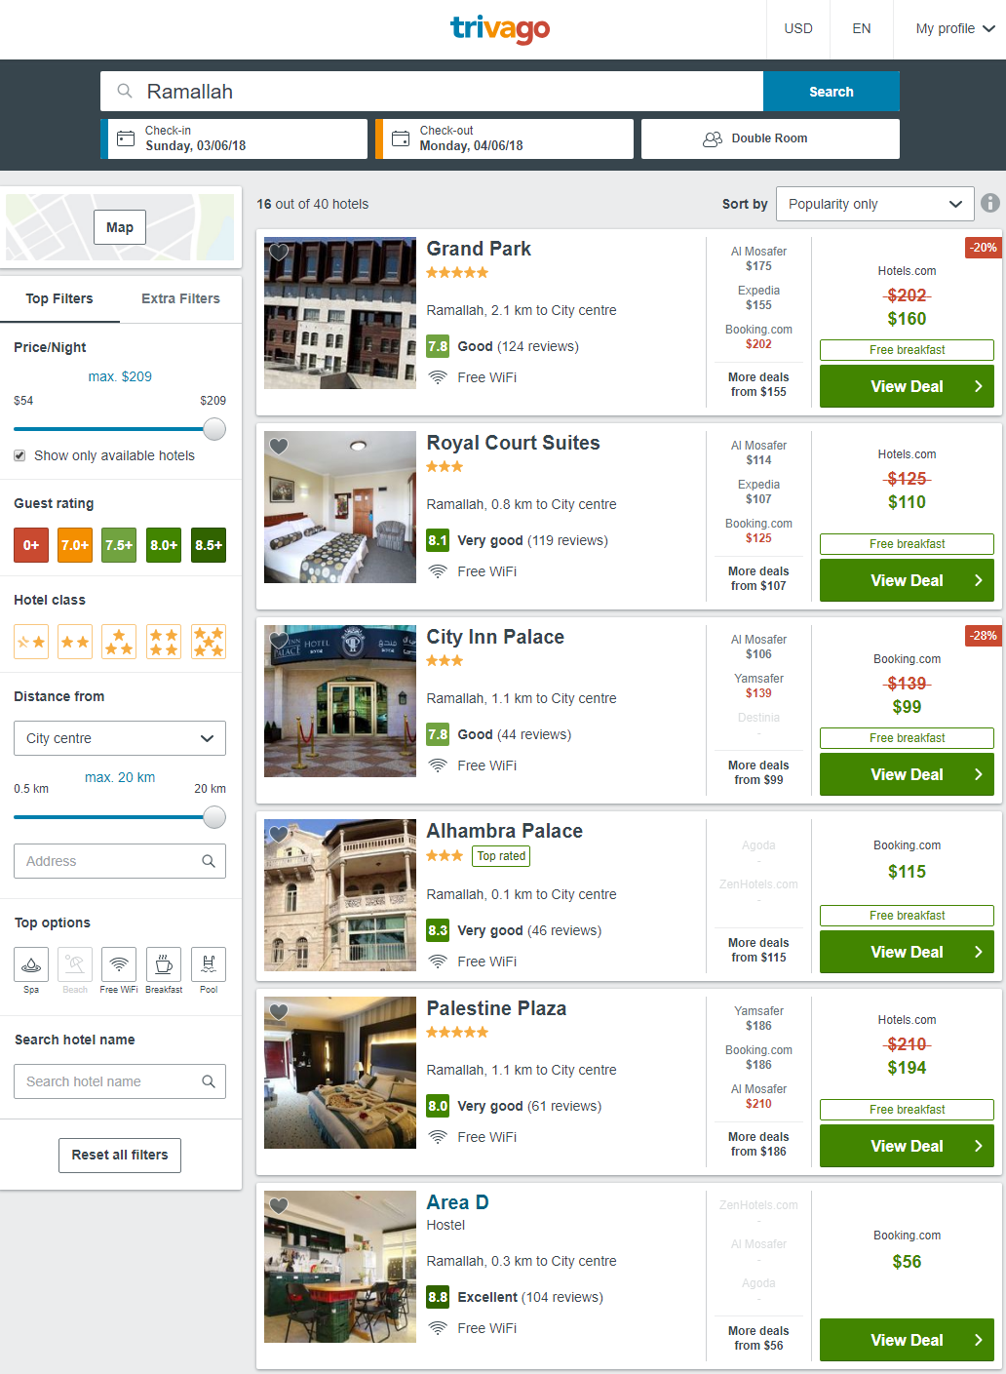

Suggested Solution(s):

1st Solution:

After searching for a location, the user redirected immediately to a map showing location of candidate hotels in the searched and targeted area and a block view showing a deal at mouse hover.

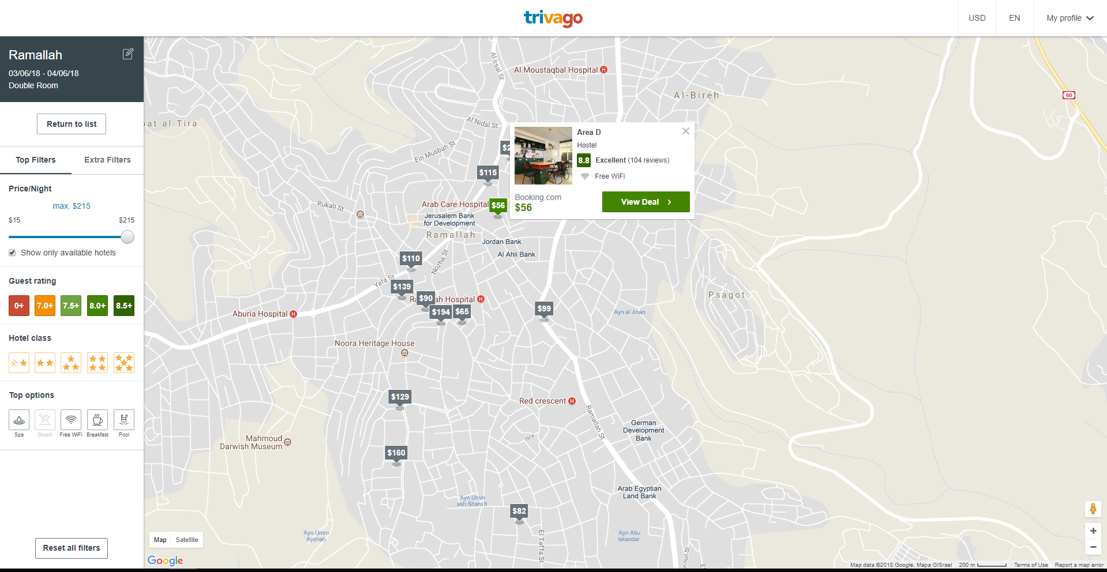

2nd Solution:

After searching for a location the user presented a grid view of hotel deals and provides the ability for changing sorting technique and choosing the ascending and the descending order.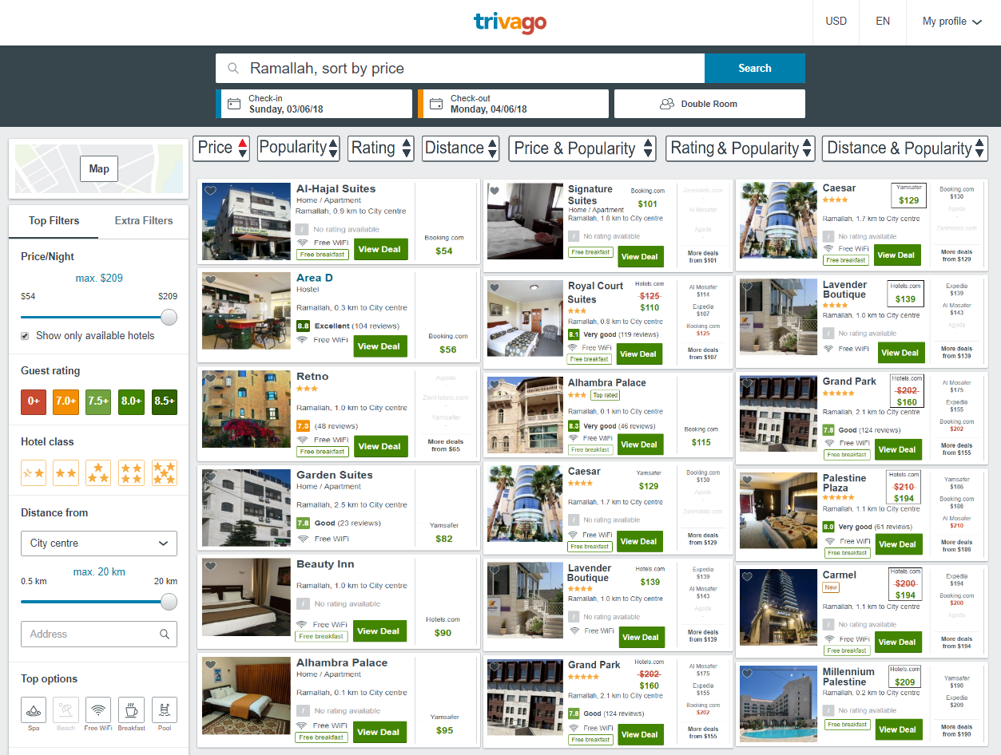

Null Hypothesis:

**There is no difference with subjects satisfaction between the old design and the new designs.**

Independent Variable:

Our independent variable is the **Design Type ,** we are manipulating multiple designs the current and a suggested (two) designs in order to get to the appreciated design that reaches our user satisfaction which is the dependent variable.

1.Old design.

2.map design.

3.Grid design**.**

Conditions:

**1.Old design.**

**2.map design.**

**3.Grid design.**

Dependent Variable:

**user satisfaction is** our only dependent variable , since it responds to the change we are trying to make on the three suggested designs, the old (current ) and the two new ones, after all ,our measuring factor which directly reflects our designs is user satisfaction and the way to increase it.

Subjects & Data Collection Technique:

The subjects are the 4th year female students of Commerce College.

Using the With-in group Technique.

We will use google forms and shuffle the order of the designs to measure subject’s satisfaction.

Grouping:

Within Group Design:

All participants will be presented the three conditions then we use the questionnaire answers to detect user satisfaction on each condition.

Questionnaire Questions:

1. Which design satisfies your needs the most?

2.Which design was easier to find what you need ?

3.Which design was faster to find what you need?

4.Which design was most visually appealing?

5.How likely would you recommend this design to a friend?

Data Analysis Technique:

Repeated Measures ANOVA:

We will take all the data we gathered from the within group experiment on the subjects and compare them using the “repeated measures ANOVA” to check if there is any difference in the subject satisfaction between the designs and to check the null-hypothesis if it is right or wrong.